Looking for a nonpartisan presentation on
CLIMATE CHANGE?

Look no further!

The Madison Chapter of Citizens’ Climate Lobby
has qualified local presenters who
have spoken to faith communities, garden clubs,
civic groups, engineers, health care professionals, etc.
Our presenters share climate change basics and the impacts
it will have on your particular interest area.
They discuss solutions and offer opportunities to take action.
CCL also has access to many climate change documentaries.

See back for details!

Looking for a nonpartisan presentation on
CLIMATE CHANGE?

Look no further!

The Madison Chapter of Citizens’ Climate Lobby
has qualified local presenters who
have spoken to faith communities, garden clubs,
civic groups, engineers, health care professionals, etc.
Our presenters share climate change basics and the impacts
it will have on your particular interest area.
They discuss solutions and offer opportunities to take action.
CCL also has access to many climate change documentaries.

See back for details!
Looking for a nonpartisan presentation on
CLIMATE CHANGE?

Look no further!

The Madison Chapter of Citizens’ Climate Lobby
has qualified local presenters who
have spoken to faith communities, garden clubs,
civic groups, engineers, health care professionals, etc.
Our presenters share climate change basics and the impacts
it will have on your particular interest area.
They discuss solutions and offer opportunities to take action.
CCL also has access to many climate change documentaries.

See back for details!

Looking for a nonpartisan presentation on
CLIMATE CHANGE?

Look no further!

The Madison Chapter of Citizens’ Climate Lobby
has qualified local presenters who
have spoken to faith communities, garden clubs,
civic groups, engineers, health care professionals, etc.
Our presenters share climate change basics and the impacts
it will have on your particular interest area.
They discuss solutions and offer opportunities to take action.
CCL also has access to many climate change documentaries.

See back for details!
Typical timeframe: 45 to 60 minutes + Q&A
Audience size: 5 to 100+
Contact: Barbara Feeney, bafeeney@gmail.com to discuss a presentation for your group or organization.
www.madisonccl.info

About Citizens’ Climate Lobby
Citizens’ Climate Lobby is a nonpartisan, nonprofit organization empowering people from all walks of life to become effective advocates for a livable world.

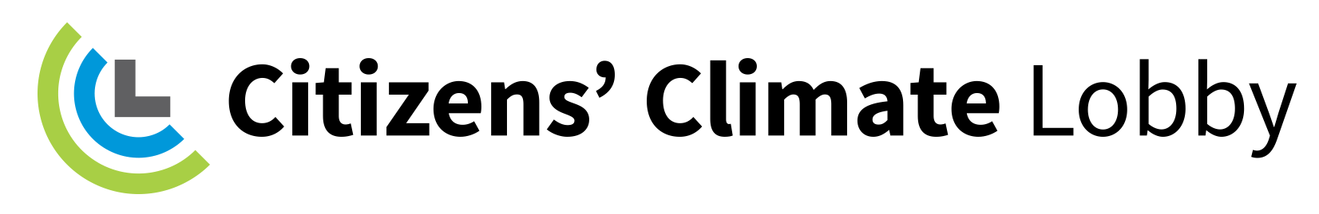
CitizensClimateLobby.org

Typical timeframe: 45 to 60 minutes + Q&A
Audience size: 5 to 100+
Contact: Barbara Feeney, bafeeney@gmail.com to discuss a presentation for your group or organization.
www.madisonccl.info

About Citizens’ Climate Lobby
Citizens’ Climate Lobby is a nonpartisan, nonprofit organization empowering people from all walks of life to become effective advocates for a livable world.

CitizensClimateLobby.org

Typical timeframe: 45 to 60 minutes + Q&A
Audience size: 5 to 100+
Contact: Barbara Feeney, bafeeney@gmail.com to discuss a presentation for your group or organization.
www.madisonccl.info

About Citizens’ Climate Lobby
Citizens’ Climate Lobby is a nonpartisan, nonprofit organization empowering people from all walks of life to become effective advocates for a livable world.

CitizensClimateLobby.org

Typical timeframe: 45 to 60 minutes + Q&A
Audience size: 5 to 100+
Contact: Barbara Feeney, bafeeney@gmail.com to discuss a presentation for your group or organization.
www.madisonccl.info

About Citizens’ Climate Lobby
Citizens’ Climate Lobby is a nonpartisan, nonprofit organization empowering people from all walks of life to become effective advocates for a livable world.

CitizensClimateLobby.org

